Project 3 description

our product is now focused on creating a nighttime routine that incorporates elements of creating a proper sleep hygiene.

Sequence 1: Coming back from work
Scene 1.1
Wendy comes home from work late. She is stressed out and tired and still has a few things that she needs to finish up in preparation for tomorrow’s presentation.
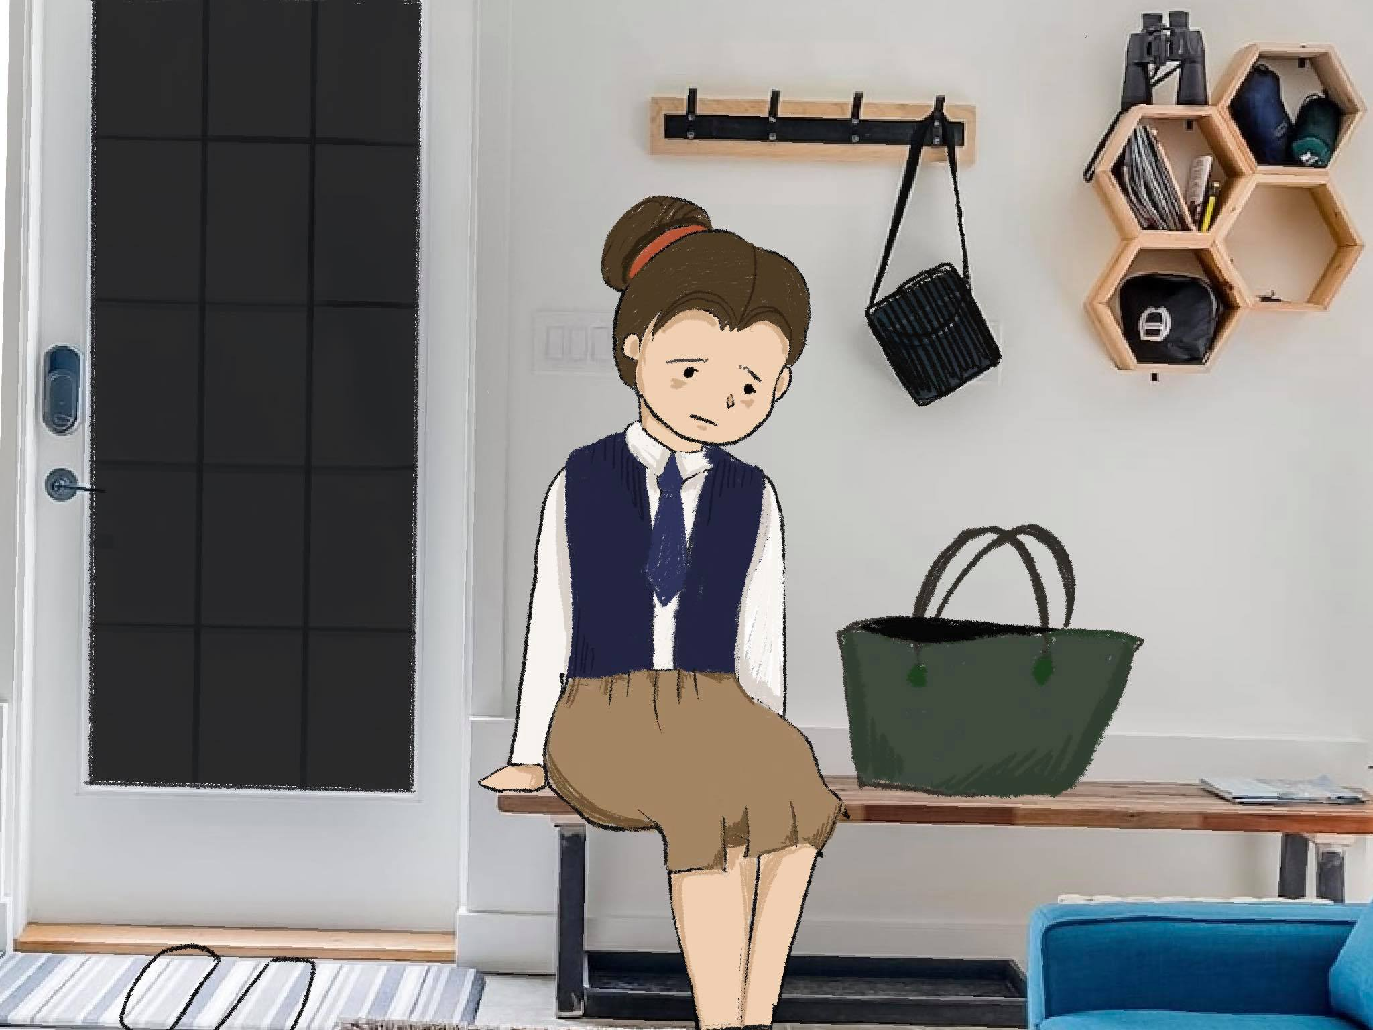

Scene 1.2
As a young working professional who lives alone, Wendy experiences a lot of stress that impacts many aspects of her life, such as her performance in work or her sleep hygiene.

Before overextending herself again, she gets a notification from Serenity. VUI: “You have been working for quite some time. It’s getting late.”

She turns off her laptop and heads to the bathroom. It’s time to take a shower.

Image(s) on screen during voiceover:
Sequence 2: shower and skincare
Scene 2.1
VUI: “Don’t forget to adjust the temperature. A lukewarm shower is just right, it will help you unwind and fall asleep faster, also makes breathing easier at night.”
Serenity starts to play music from Wendy’s favorite spotify playlist Image(s) on screen during voiceover: 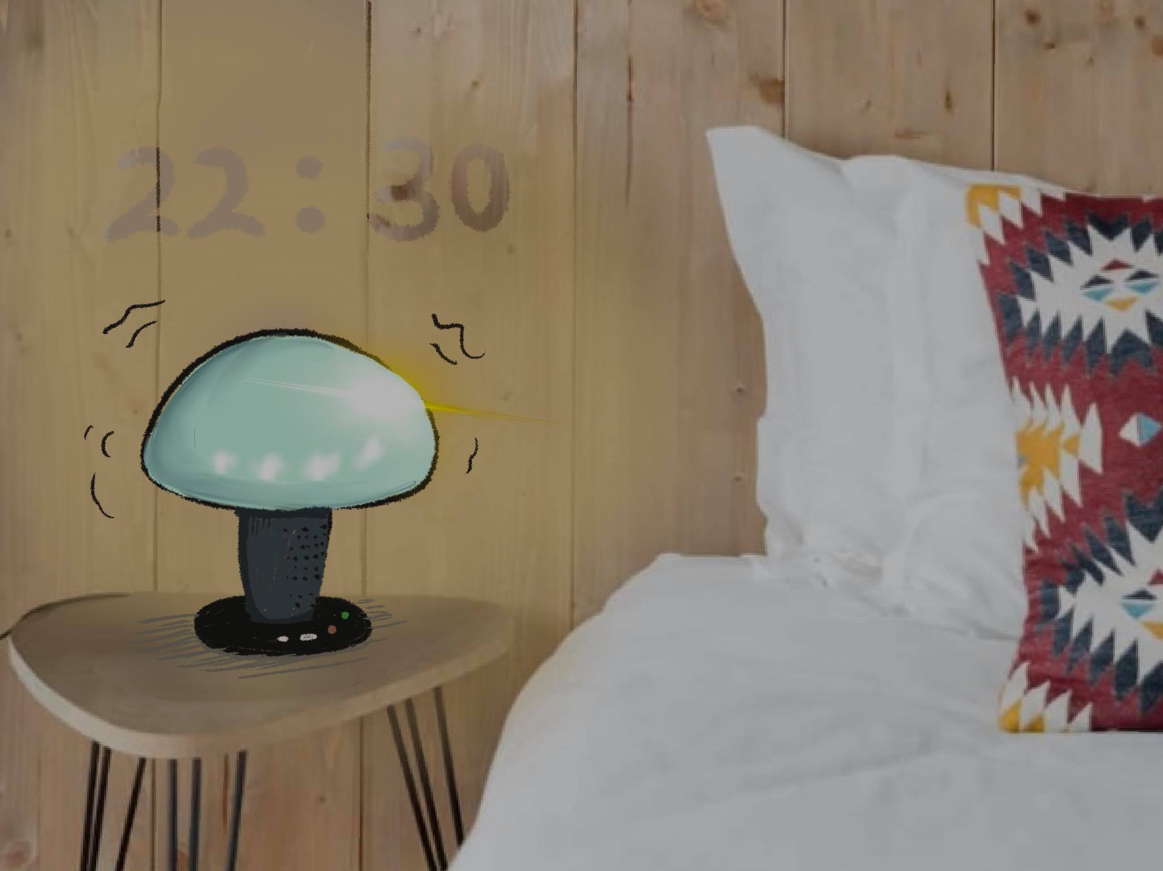
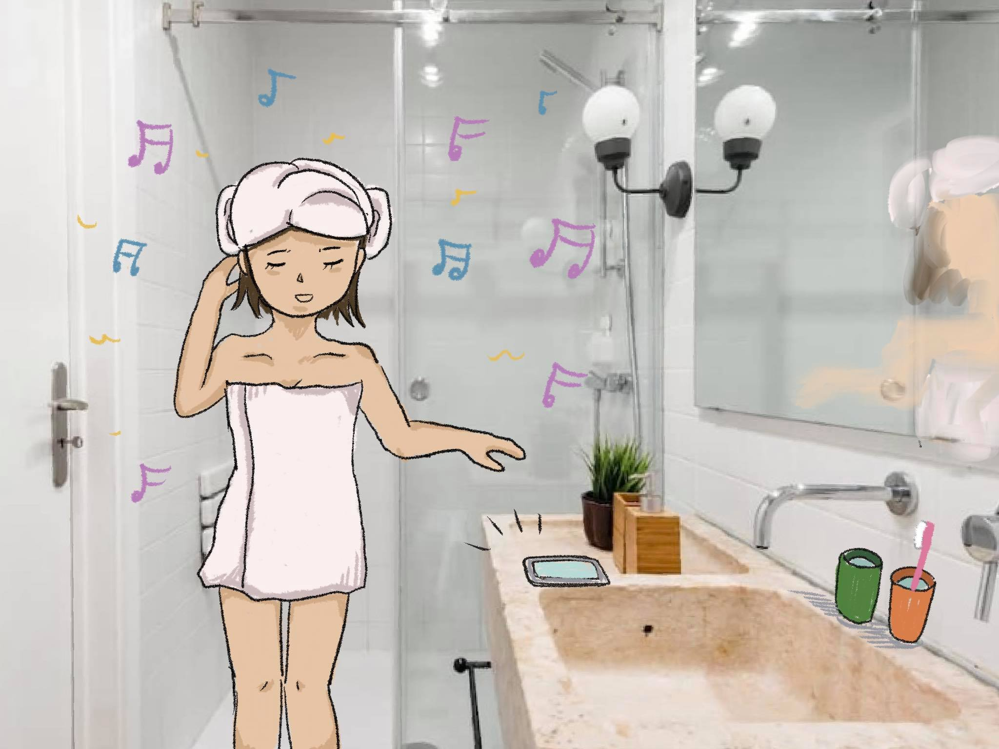
Scene 2.2
Voiceover: After a relaxing shower, Wendy begins her skincare routine. While she puts on her facemask and brushes her teeth, Serenity suggests that she uses the time to reflect on her day.
VUI: “Close your eyes, now think of the top three things you learned today.”
“Good! What about one happy moment from today?”
“Also, name one person that helped you today.”
“That’s perfect. Now here are some skincare tips for today: ......” (volume down gradually)
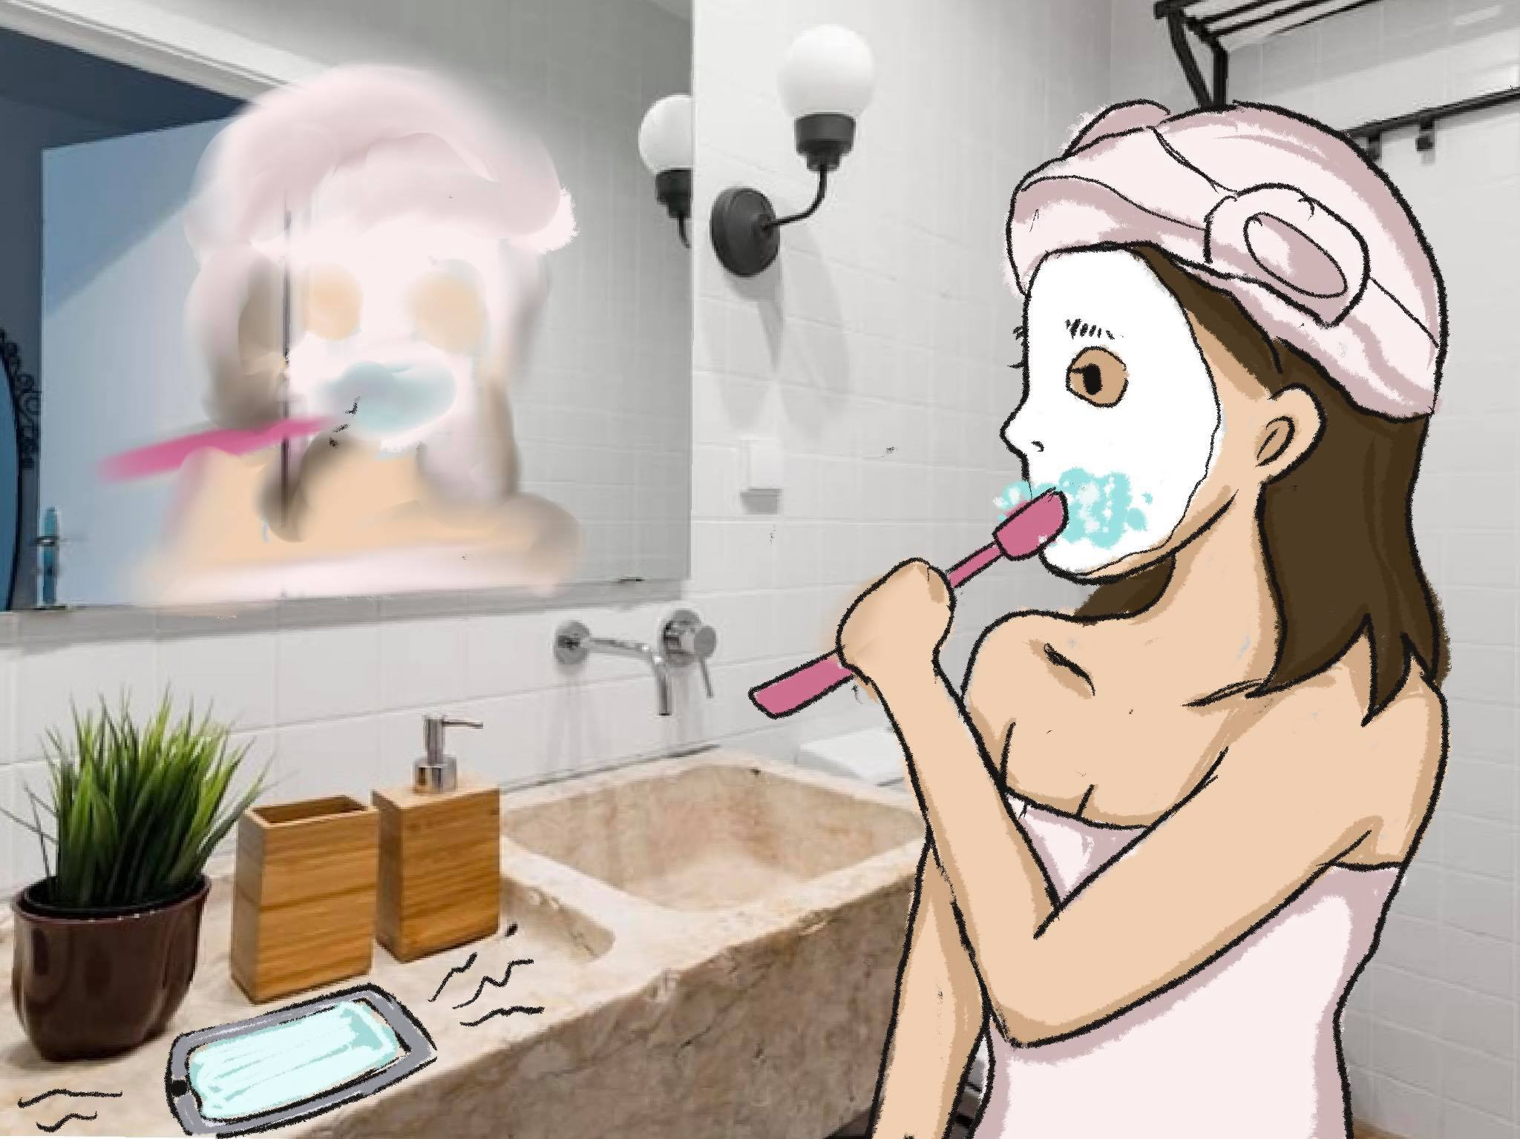

Sequence 3: sleep
Scene 4.1
Even after her relatively relaxing nighttime routine, Wendy feels that there are many things on her mind that keep her awake. She just can’t seem to fall asleep because of worrying all the time.
Wendy decides to consult her nightstand companion. From the tone of her voice, Serenity knows that Wendy feels rather anxious. The lamp asks a few questions such as
VUI: “What’s on your mind? Are you having difficulties falling asleep?”

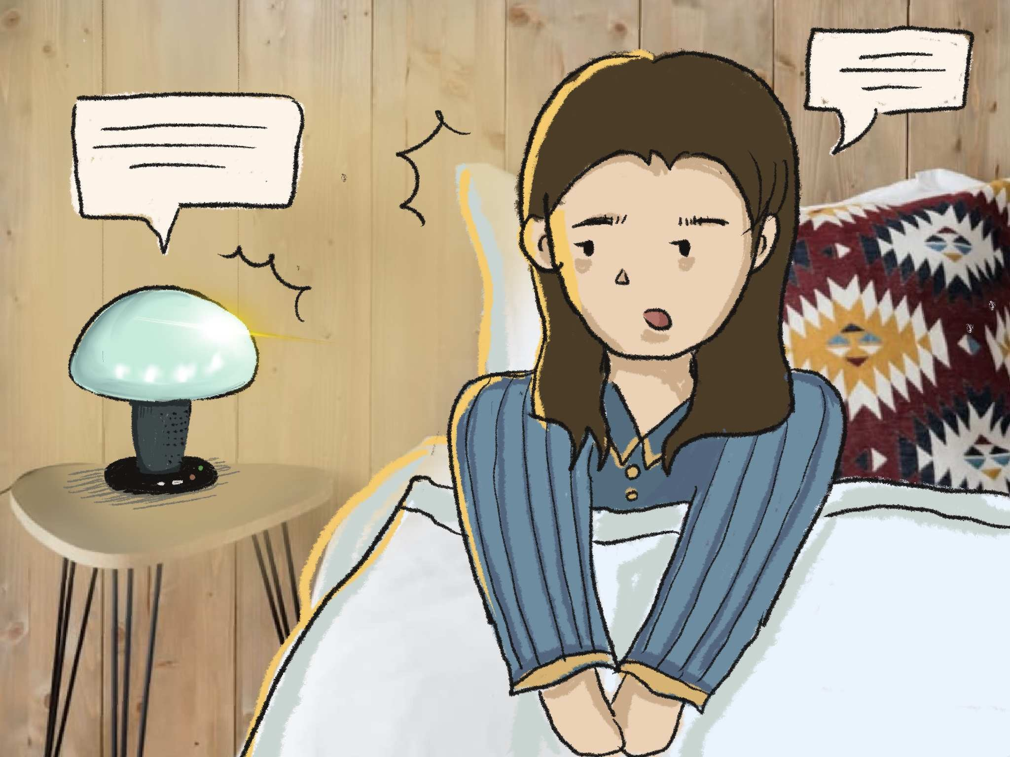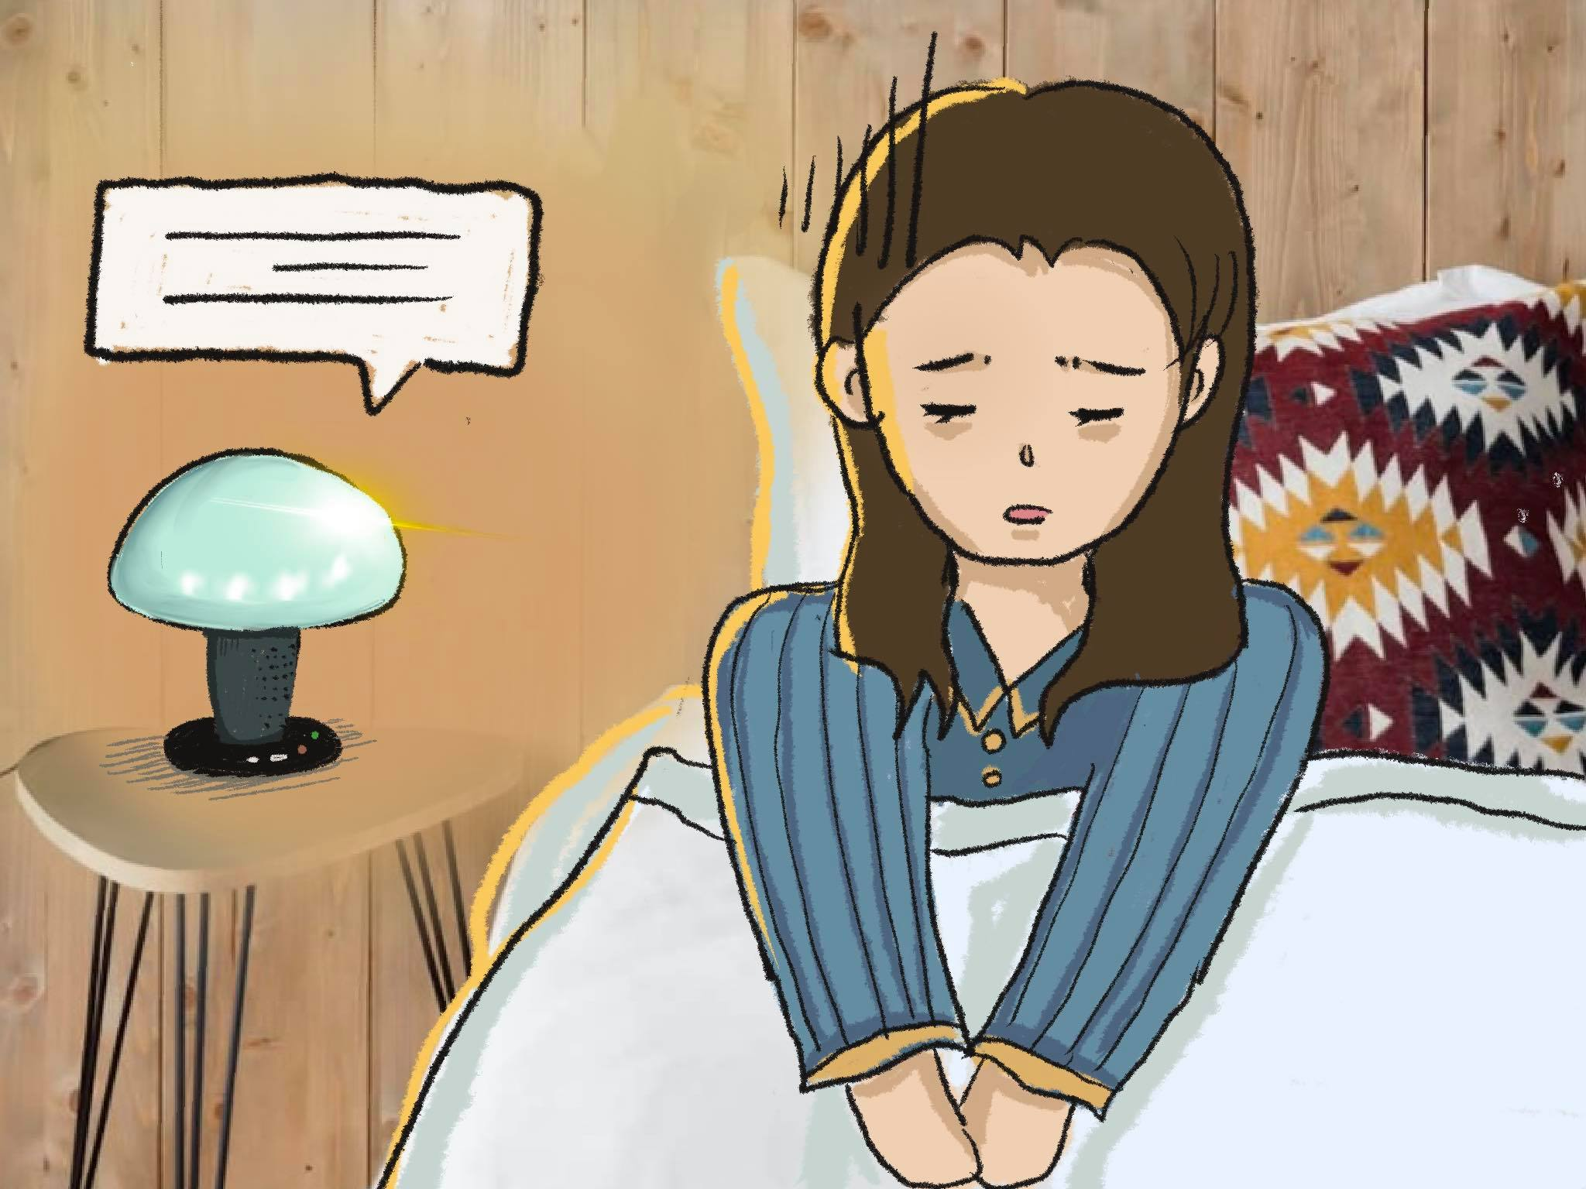
The voice assistant attempts to find out the reason why Wendy is not falling asleep.
After analyzing keywords and emotions, Serenity determines that Wendy is suffering from stress caused by work and that she is worried about the next day, so it initiates an activity called “voice diary”. Following its guidance, Wendy talks about her ruminations and feelings and mentions. Her conversation with Serenity is recorded and synced with her phone, which keeps track of her thoughts and feelings.

Scene 4.2
After this, Serenity proposes a verbally guided meditation exercise to help Wendy relax and de-stress during which Wendy is encouraged to visualize a calming location.
Light is dimmed, and soft, calming music starts to play. For the first time in a long while, Wendy feels calmer than ever and falls asleep.
